Perform tht following ta»ks.

Task 1: Declare two integcr arrays, A end B, of size 5 Take user input m» both arrays and determine whether ihe lwo arrays are identical or not. Two arrays are identical if both contain same values at same indices. Prim ldentiral” or Not identical” based on your finding.

1”ask 2: Read 10 integers from the user and store them in an array. ”Fake another integer from the user and check whether it is in the array (print “Found“ in that case) or not (print “Not found“).

Task 3: Read 10 integers yrom fhe user and storc them in an array. Then find the largest eJcment in the array.

Perform tht following ta»ks.

Task 1: Declare two integcr arrays, A end B, of size 5 Take user input m» both arrays and determine whether ihe lwo arrays are identical or not. Two arrays are identical if both contain same values at same indices. Prim ldentiral” or Not identical” based on your finding.

1”ask 2: Read 10 integers from the user and store them in an array. ”Fake another integer from the user and check whether it is in the array (print “Found“ in that case) or not (print “Not found“).

Task 3: Read 10 integers yrom fhe user and storc them in an array. Then find the largest eJcment in the array.



6:51

9 docs.googIe.com

Def1ne a function "multiply" that 10 points

computes and returns the product of the type int elements of its array input argument. The function should have a second input argument telling the number of array elements to use.

,;j¿, Add file

10 points

‹ ›||‹ ›\\ i i T‹' (\\'‹ › li I S”

8 53 32 54 7 4 3 7 18 28 37 42 42



,Z, Add file

How could you modify the 10 points

selection sort algorithm to get the scores in descending order (largest score f1rst)?

,g, Add file



Name:

ID:

Sec:

**Array**

1. Write down a single program that will take 11 integers as input using a loop and perform the following tasks in sequence in the same program:
   1. Check whether the middle element of the array is odd or even*
   2. Interchange the first element with the last element.
   3. Starting from index 0, print every alternate elements of the array.
2. Take 5 students’ marks as input and store them in array. Then find the average marks. Finally, find and print how many of them got above average marks and how many of them got below the average.

Enter array elements: 50 60 70 75 90

Average is 69

3 of them got above average 2 of them got below average

1. Take N integers as input and store them in array. Then ask user for an integer x and search the whole array for x. If found, then display how many times it occurred in that array. Display “not found” otherwise. N will also be input to your program.

Input

Input size of array: 10

Input elements in array: 10, 12, 20, 25, 13, 10, 9, 40, 60, 2S Element to search* 25

Output

Element found 2 times



1. Take user in put f0r an int array of size N and determine whether the array is sorted in ascending order or not. N will also be input to your program.

[Hint: in s0rtRd array, eaEh eIE'ment (except the last one) is USS than or equal to the nRxt

on e]

Enter array elements: 7 2 0 1 7

Not sorted

Enter array elements: 5 8 8 13 20

Sorted

1. Take N numbers as input and store them in array. Shift all elements of the array one place towards right. See the example below:



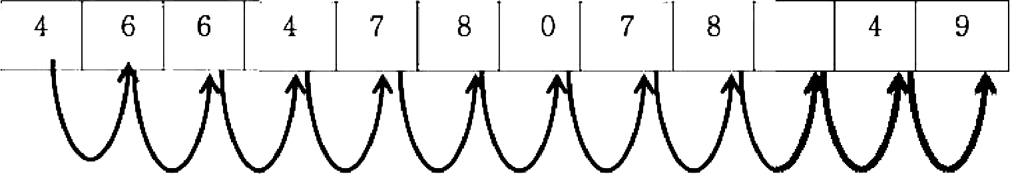

1

IO



###### 4 6



10

10



9

@ You Tube X Lab Evaluation : 03 

*— a* x

  



2 Takr usrr input for an integer array of sitr N and drtrrminr whrlhrr me array is sortrd or not

N w‹II also be Input to your progt am. If ear led, pr‹nt whether +s ‹t a*cend‹ng or descending

|Hlnt A sortrd orray could be sorted rather ‹n asrrnd•ng or de sc rnd•ng order. In an arroy sorted n a+cend‹np or del, each element (e•¢ept the IaM one) i¥ Ie*+ than or equal to the next one. whereas •n descending older. each element le•cept the Inst oneI •s greater then or equ4l

E ntcr N S

k nter array elements

S 8 8 y3 20

sorted Ascending

Add file

Enter N. 5 F nter M: S

knter array elern em+ £ nter array element s

7 2 0 y 7 20 8 8 S 2

Not soned doned Descending





,0 Type here to search



8/29/2020

O

@ You Tube X Lab Evaluation : 03 X Lah E'.aIuati:n' 33 SET 23 x *•fi•*

{2 9 docs.googIe.com ’Ie rnas d e,’ 1 SAI pQL S cF.'. XAn4glfisUC H‘-Xq nx9dqlzF * ^s^h eG 50 ^RH or«s iQ . ie\•.jc'rm

0 T--LINK 0

*— G* X





Suppose we have an array of t0 lIoat›ng point number s where an element can be repeated. Write down a program that will find the maximum of all these 10 numbers and will Why print exact Iy in which Inc+tiun(S) within Ihe array it appears. The number of elements in the array and the array clements will be nput to your program, For example if your array is: (10)

(3.0. S.5, 2.0. 6. T. 7.0. 8.0. 9.0, 2.0. t.0. 4 0)

Then your program should prim the followings:

The maximum Is 9.0 and Tt appeared in location 6, On the other hand if your array is as follows:

‹3.0. s.0.2.0, 0.0. 0. 8.0, 9.0.2.0. 0 0. 4.0)

Then your program should print the followings.

The znsyTmum Ts TO and It oppearad Tn Ietw 3, g,

Add file

,0 Type here to search



8/29,7020



 

ü docs.googIe.com 

O TP MNK O

Shows the required nested loop to find the summation of all elements in the upper triangle of an N X N square matrix. (You don t need to \’vrite the whole program. just show the loop nesting). For example. for the following matrix the output will De 15.

|  |  |  |  |  |  |
| --- | --- | --- | --- | --- | --- |
| 0 | 1 | 1 | 1 | 1 | 1 |
| —1 | 0 | 1 | 1 | 1 | 1 |
| 1 | 1 | 0 | 1 | 1 | 1 |
| —1 | —1 | —1 | U | 1 | 1 |
| —1 | —1 | —1 | —1 | 0 | 1 |
| —1 | —1 | —1 | —1 | —1 | 0 |

FULL ŒIT A NEW

RESP'ONŒ

You're editing your response. Sharing this URL allows

others to also edrt youi response.

,0 Type here to search



11:51 AM

0/5/2020



.p .g CSE 115L: Programming Language I Lnb

' JqJ Assignment 01, Summer 2020, Sec: 13

Total: 30, Submission Date: **21.08.2020**

1. Write a C prugram tu deirte dupkate eicrrerts ihr any number ßom array, tm array

Snmple into oidput:

Enter a size: 10

Enler array ekrrimis . 1 2 3 4 4 5 5 6 6 7 Thr array with dupkates de¥•ted.

1 2 3 4 5 d 7

1. Wräe a C prugram tu eonvert a hexadecknil nrrber lu bäuuy nixrber system 1ß puints
2. Write a C program to prxit the givrn pattern iarig km 1 up. 

Summe into output: Enter no of ruws: 5 Fmter im of culmns. 5 ABCDE

BCDEA

CDEAB DEABC EABCD

Facebook X for Ek Kothaye | 8esh Korechi Pr X Ciasswork for CSM I S Summer 2 X Assignment 4 

C2 g docs.googIe.com/forms/d/e/J FAIpQL ScKZRY5yP2PQRR#xAr6JAwuUOkdvv2SYxOLNYQ26u Lxsmk9A/viewform?hr submission=ChkIn-CmjcQDEhAIz77a9aA££g¢l6sjZka4DEAE

### Assignment 4

The name, username and photo associated with your Google accounl will be recorded when you upload files and submit this form. Not [**emaz.ahmed@northsouth.edu?**](mailto:emaz.ahmed@northsouth.edu) Switch account

Untitled Ouestion

Write a function named remo\-e char" in 0 that takes a string as parameter which removes

characters in string parameter excepi alphabets.

Tagut: nonbsoutbTco3o4

**Oupal:** nodhsomhcom

Add file

Untitled Ouestion 10 |›o nts

Write a function named replace char” in C ihnt takes a string as parameter wlich replaces the

spaces o-ith a specific character in siring rameler.

lest **Data:**

£•pu¥: Be glad to sez the hack oF

Outgut: Be’glad”Io*see'the"back"o "

T Add file

*- a* x





,0 Type here to search

Untitled Ouestion 1 0 poin Is





ENG 11:S4 AM

u5 9/25/2020

* 1. Facebook X for Ek Kothaye | 8esh Korechi Pr X Ciasswork for CSEJ IS Summer < X Assignment 4

W g docs.googIe.com/forms/d/e/J FAipQL ScKZRY5yP2PQRR4xAr6JAwuUOkdvv2SYxOLNYQ26u Msmk9A/viewform?hr submission= Chkln-CmjcQDEhAlz77a9aA£Egcl6sjZka4DEAE

T Add file

Untitled Ouestion

Write a fuoctioa aazoed count tbe” io C wbicb couats tbe ouzaber of times a givea word “tbe” appears in the siring pazameler.

lest Data:

Nagel: Tbe string abere tbe word tbe present roore tbao oace.

Add file

Untitled Ouestion

Write a function named split stnng” in C which splits string parameter **by space** info «-ords.

Test Data•

Papua: Llsis is a test sWAg



* Add tile

Untitled Ouestion

*- a* x







@ Type here to search

Write a fbnclioa named “gel sum” in C which calculates the sum of numbers from I Io n using





LNG 11:S4 AM US 9/25/2020

Facebook X @ for Ek Kothaye | 8esh Korechi Pr X @ Ciasswork for CSE1 IS Summer < X @ Assignment 4 

W g docs.googIe.com/forms/d/e/J FAipQLScKZRY5yP2PQRR4xAr6JAwuUOkdvv2SYxOLNYQ26u Msmk9A/viewform?hr submission= Chkln-CmjcQDEhAlz77a9aA£Egcl6sjZka4DEAE

Add file

Untitled Ouestion

Write a functioa named "get sum" in C H'hich calculates the sum oF numbers from I to n using

**Test Dafa:**

apu:

Octpu‹: 15

Add file

Untitled Ouestion 4 0 porn is

Write a function named "get wer" in C which calculates the power of any number using



Test **Data:**

npu sse:

fi•pu£ power• 6

**Outpui: 64**

Add f ile

Untitled Ouestion 10 pa in Is

*- a* x







@ Type here to search

Wrile a fñnclion named "prim array" in C which prinls the array elemenls using recursion.





LNG 11:SS AM US 9/25/2020

Facebook X Tor Ek Kothaye 8esh Korechi P‹ X Ciasswork lor CS£J IS Summer 2 X @ Assignment 4

W g docs.googIe.com/forms/die/J FAipQL ScK ZRY$yP2PQRR4xAr6JAwuUOkd v2SYxOLNYQ26u Lxsmk9A/viewform?hr submission= Chkln-CmjcQDEhAlz77a9aA£Egcl6sjZka4DEAE

**o»ie«i:** u

T Add file

Untitled Ouestion

Wrile a funclion named "prin! array" in 0 which prinls Ihe array elemenls using recursion.

Hague eleeseoy*: 2 4 6 8 10 1 2

Outlet: 2 4 6 8 10 12

Add fila

Untitled Ouestion

Wrne a function named "count digils" in C which counl the digits of a given number using recursion.

Test Daea:



T Add file

Submit

This form was created inside of North south university. sport Abuse



E# Type heretosearch



— o x



LNG t 1:US AM US 9/25/2020

Name:

SE 5: ass n ent

ID: Section:

1 If a four-digit number is input through the keyboard, write a program to obtain the product of the first and last digit of this number.

1. Mr. Alam’s basic salary is input through the keyboard. His dearness allowance is 40% of the basic salary, and house rent allowance is 20% of basic salary. Write a program to calculate his gross salary (gross salary is the summation ot basic salary, dearness allowance and house rent allowance).
2. y = 2x3 + xz - 7. Ask the user for value of x. Then compute and print the value of y.
3. Write down a program that will take the length of two items measured in meters and centimeters as input and will print their length difference in meters and centimeters. For example, if the length of one item is 3 meter and S0 centimeter and the length of the other item is 2 meter and 70 centimeter then the difference that you need to display in your program is 0 meter and 80 centimeter.
4. The distance between two cities (in km.) is input through the keyboard. Write a program to convert and print the distance in (i) meters, (ii) feet, (ii) inches and (iv) centimeters. (1 meter = 3.28 feet).
5. Write down a program that will take an English letter as input and will print the letter which comes after N letters in the alphabet. N will also be input to your program. For example, if the user enters D and the value of N entered by the user is 3 the output will be G.

Name:

SE 5: ass n ent

ID: Section:

1 If a four-digit number is input through the keyboard, write a program to obtain the product of the first and last digit of this number.

1. Mr. Alam’s basic salary is input through the keyboard. His dearness allowance is 40% of the basic salary, and house rent allowance is 20% of basic salary. Write a program to calculate his gross salary (gross salary is the summation ot basic salary, dearness allowance and house rent allowance).
2. y = 2x3 + xz - 7. Ask the user for value of x. Then compute and print the value of y.
3. Write down a program that will take the length of two items measured in meters and centimeters as input and will print their length difference in meters and centimeters. For example, if the length of one item is 3 meter and S0 centimeter and the length of the other item is 2 meter and 70 centimeter then the difference that you need to display in your program is 0 meter and 80 centimeter.
4. The distance between two cities (in km.) is input through the keyboard. Write a program to convert and print the distance in (i) meters, (ii) feet, (ii) inches and (iv) centimeters. (1 meter = 3.28 feet).
5. Write down a program that will take an English letter as input and will print the letter which comes after N letters in the alphabet. N will also be input to your program. For example, if the user enters D and the value of N entered by the user is 3 the output will be G.



Name: ID: Section:

**CSE 115: Practice session:** Week 2

* 1. If a five-digit number is input through the keyboard, write a program to print summation of first and last digit of the number. For example if the number that is given as input is 12398 then the output should be displayed as 9.
  2. 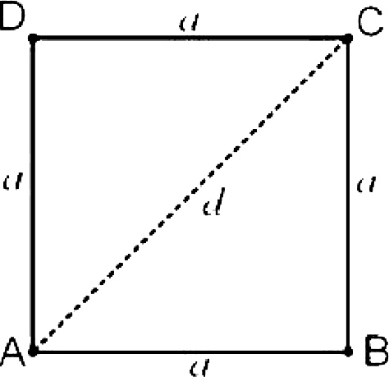[*”] Suppose the diagonal of a square is *d.* Draw a diagram of a SQUARE and find an equation for the area *A* of the square from its diagonal d. Finally, write down a program that will take the length of its diagonal *d* as input and print area of the square. For example if diagonal is 6.0 then the area will be 18.0.
  3. If the marks obtained by a student in three different subjects are given as input through the keyboard, find out the total marks and percentage marks obtained by the student. Assume that the maximum marks in each subjects is 100. Show the percentage of marks up to 2 decimal places. Your output should match exactly with the following format:

Example:

Enter subject 1 mark: 75.0

Enter subject 2 mark: 80.0

Enter subject 3 mark: 90.0

The total is 75.0+80.D+9D.0 = 245 Average is 81.67

* 1. Write down a program that will take an English letter as input and will print the next letter in the a iphabet. For example, if the user enters D the output will be E.

fereboot 

— £J X

,0 Type here to search

Ans'wer an\ 4 IFO UR ›

Write down a program that will take a character as an input and \‘vilI check whether the character entered is the English letter t. h or something else. Ignore cases. You are only allowed to use thie switch-case statement.

Simpk input/output:

*Enter the character.' t*

*En ter the character: h*



Enter *the character: T*

*Enter the character: p Something different*

rogrammer in Rupali Bank and you are in charge of calc ulating bank fees payable at the end of a month by all





Name: ID:

CSE 115: Practice session: Data types

SEC:

1. Write down a program that will take two integers as input and will show the results of addition, multiplication, division and modulous. The output should exactly match the following format but the data input will be different:

Enter an integer: 46 Enter another integer: 34 46 PLUS 34 EQUALS 80

46 - 34 = 12

The result of multiplication is 1S64 46 mod 34 = 12

2 Write down a program that will interchange the value of three variables in the following order:

a -3' b •3' c •3' a

Somp7e inp«t/output:

Enter a: 10

Enter b: 20

Enter c: 30

After interchange a = 30, b = 10, c= 20

1. [””] Write down a program that will convert a user’s time given as input in seconds into hours, minutes and seconds. For example if the user’s time is 18,247 seconds then converted time will be S hours 4 minutes and 7 seconds.
2. [’’’] Write down a program that will take two persons’ height as input (in feet and inches) and will print the difference of height in feet and inches. Assume that the taller person’s height will be always given as input first.

Sample *input/ourpizt:*

First person:

Enter feet: S Enter inch: 7 Second person: Enter feet: 3

Enter inch: 8

difference: 1 feet 11 inch

## For the same structure o1’ question number 4, instead of fill up an army, cTeate a linked list, thai find the highest salary by traversing the list from the begiiuiing and print it. 10

##### For the same structure of question number 4, alter filling up the array, write all information into a bind *YLIe* named employee.db. 10

c *c -* •*• c » c -*

Answer any 4 question.

Write a C program that prints all even numbers between m and n (m,n are user inputs)

except the ones which are divisible by 3. 10

Sample input/output:

Enter m: 99

Enter n: 1 16

All cvcn numbcrs bctwccn 100 and 112 except thosc divisible by 3 arc: 100, 104, 10ii,

110, 112, 1 16,

* 1. Writc a C program using function that rcads a floating-point uurnbcr n and an intcgcr d and thcn prints thc roundcd valuc of n up to d dccimal placcs. E.g. for u=5.628 and d = 2; it shouldprint5.68. 10
  2. Declare two strings A and B of size 100 and 50, respectively. Then take user input of both strings. Concaienate (job) B at the end of A using pointer. display the corcstenated string, You cannot use library function Ie perform the concotenation, 10

Sample input/output:

Enter first string: Baogla

Enter second string: desh

After joining, first string: Bangladesh

* 1. Create a struct called “Employee“ with the following members:
     1. Namc
     2. Date of Birth (D.O.B., in short)
     3. Starting Datc
     4. Salary

Create an array of x employee variables, where x is the 7" digit of your id; then read user input to fil1 up this array. Display ihe average salary of the employees. Then display the info of the employee who gets the highest salary. 10

4:15 PM 0.0KB/s & 

1. FINAL SECTI... ¥* F¿¡ f

**Depaztzoeat** og **El”ecfzical** azsé **Coosputer EogLoeeriog CSE 1l5L: Programming language I**

**Time: I hnnr 20 Minutes FINAL EXAM**

* 1. Creaie a function named **stadentlnfo.** Take ten studenis Totalmarks, name, id using structure frnm user Input. Now Fmd all the ourks which are

dix isible by 9 and Print the student *N*am*e.* Id.

Also. Siorc the divisible marks in a Structure amiy. Then pass this suucture array io maximums function. ( IO)

Now Creaie another function named meximuxm It will caiculalc ihc Third

maximum number using ihai structure wmy. Print the result. 110)

Nnw **creatr the nuiin fixnctinn and Call the necessary fiinctiun tn exee4rte**

* 1. Write n Program to find thr sum and as'erage nd this series from the 2H to 1 2 4 8 l6 32 64...
  2. Create a functlon named Employee. Take ten employee name and salary from the user and store them in two 10 arrays. Now calculate the highest and lowest paid salary and store the result In a Text file named HIghLow.txt. Also, Write all the employee names In the employee.txt file. (10)
  3. Now create a functlon named average. Read the HighLow.txt file. Tfien find the sum and average of the salaries and print In the console. (10)

• O• <

@ Final Exam H F inal exam ¥ Messenger x | t — B X

W g docs.google.com/forms/d/e/1FAlpQLSdfRsGh8ZBpt8WpUrMOjRbgOJRsG6CBHafhuosJ ukzjs18cQ/viewform?hr submission=ChklioOqqsABEhAIwY rn6oFC... 6 @ ' •

mussuwi i \u i

CSE 11*



Sq you are working €›r a ozwl agcmry. Th coagoay oBâs 30 dJd rmi too pacXzgcs



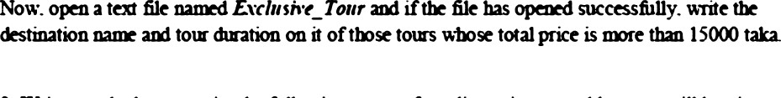



3. '4’rdc a Recursne £uorzI'oo hat cao add all tbc aua s 6oza 5 la a (alice a is greata ibaa

 ()

2.59 PM 10/5/2020



Name: ID: SEC:

CSE 115: Practice Session

* + 1. Write a program that reads a number, N, and will print the numbers between 1 and N that are divisible by the unlucky number 13. While printing print the numbers down word.

[Hints: try printing upward first and then think what changes are needed to print downwards]

* + 1. Write a C Program that prints l through n in square brackets. For example, if n = 6,

print the following

[1] [2] [3] [4] [5] [6]

Integer n will be input to your program.

* + 1. Write a program that will read N numbers using a loop and will display their sum. N will be input to your program.



Name: ID:

**Class Assignment:**

SEC:

1. Write down a program that will find the summation of the following series, n will be input to your program:

1^-2‘+3’-4’. up to n‘

**Sample Input/ Output 1:**

Enter a number: S The sum is: -81

**Sample Input/ Output 2:**

Enter a number: 10 The sum is. -575

1. Write down a program that will count how many numbers are there between n1 and n2 that are divisible by 3 but not divisible by 5. Both nd and n2 will be input to your program. Assume that n1 < n2.

Sample Input/ Output 1: Enter n1: 10

Enter n2: 200

50 numbers

**Sample Input/ Output 2:**

Enter n1: 1100 Enter n2: 11S0 14 numbers

1. Write down a program that will print all factors of a number n and the total number of factors of it. N will be input to your program, For example if N = 6, it has four factors namely 1, 2, 3, 6 and it has total 4 factors. So the output will be as follows:

**Sample Input/Output**

Enter N: 6

Factors: 1 2 3 6

Total factors: 4

Enter N: 54

Factors: 1 2 3 6 9 18 27 54

Total factors: 8

1. Write down a program that will find the summation of all odd factors of a number N. N will be input to your program. For example if N = 12, your output will be 4 because it has six factors namely 1, 2, 3, 4, 6, 12 and among those only 1 and 3 are odd. The sum is 1+3 = 4.

Name: ID: SEC:



CSE 115: Lab Class: Loo

ractice session

1. Write down a program that will print summation of digits of a number n given as input. The number of digits in the number is unknown.

**Sample 1npu§f Output 1:**

Enter a number: 1221 The sum of the digits is 6

Sample Inpu§/ Output 2:

Enter a number: 2Sh53 The sum of the digits is 21

2. Write down a program that will find the summation of all Fibonacci numbers up to N-th Fibonacci number. N will be input to your program. The Fibonacci sequence is the sequence of numbers where the next number is found by adding up the two numbers before it. Some numbers in the Fibonacci sequence:

1, 2, 3, 5, S, 13, 21, 34, 55, 89, 144, 233, 377, 610, 987, 1597, .. .

if N = 5, your output will be 1+1+2+3+5 = 12.

3 Write down a program that will find and print Lowest Common Multiplier (LCM) of two numbers x and y. The LCM is explained with an example below: Consider the numbers x = 12 and y = 15:

The multiples of 12 are : 12, 24, 36, 48, 60, 72, 84, ....

The multiples of 15 are : 15, 30, 45, 60, 75, 90, ....

60 is a common **multiple** (a multiple of both 12 and 15), and there are no lower common multiples.

[Hints: Find the maximum o/ these two numbers x and y. Let the maximum be max. Now generate multiples of max sequentially using a loop (i.e., generate 1•max, 2•max, 3•max, .....) Aside the loop check whether any of these newly generated multiples are divisible by both x and y or not. If it is then that’s a common multiple and you break from the loop with the number stored in a result variable.]

Class Assignment:

1. Write a C code that will print a pyramid of numbers like below. The number of rows N in the pyramid will be input to your program. Assume N s 9.

Sample Input/Output 1:

Enter N: 4

1

12

123

1234

Sample Input/output 2:

Enter N: 6

1

12

123

1234

12345

123456

1. Write down a program that will print a N X N square of letters like below. The number of rows or columns N in the square will be input to your program. Assume N s 26.

Sample Input/ Output 1:

Enter n: 5



BBBBB CCCCC DDDDD EEEEE

1. Write a C program to display first N prime numbers where N will be input to your program.

Sample Input/ Output 1:

Enter n: S

first S prime numbers are: 2 3 5 7 11

Sample Input/ Output 2:

Enter n: 9

First 9 prime numbers are:

2 3 5 7 11 13 17 19 23

be e C code that will print a pyramid of numbers like bełew. The jzyra*mid* will be input to your program. Assume N ż 9.

Sample Input/Output 1:

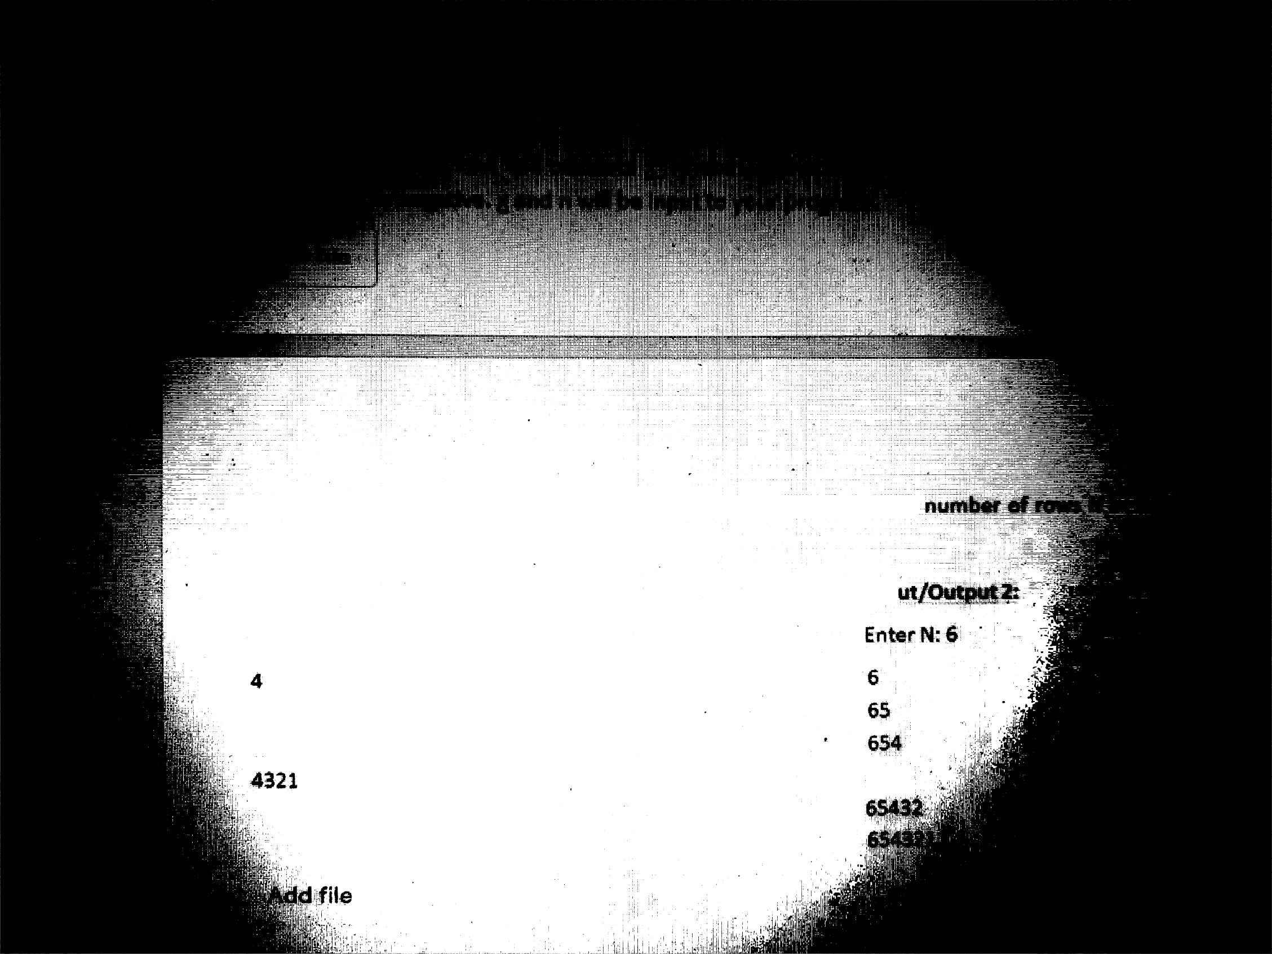

Enter N‘ 4

43

432

Sample łnp

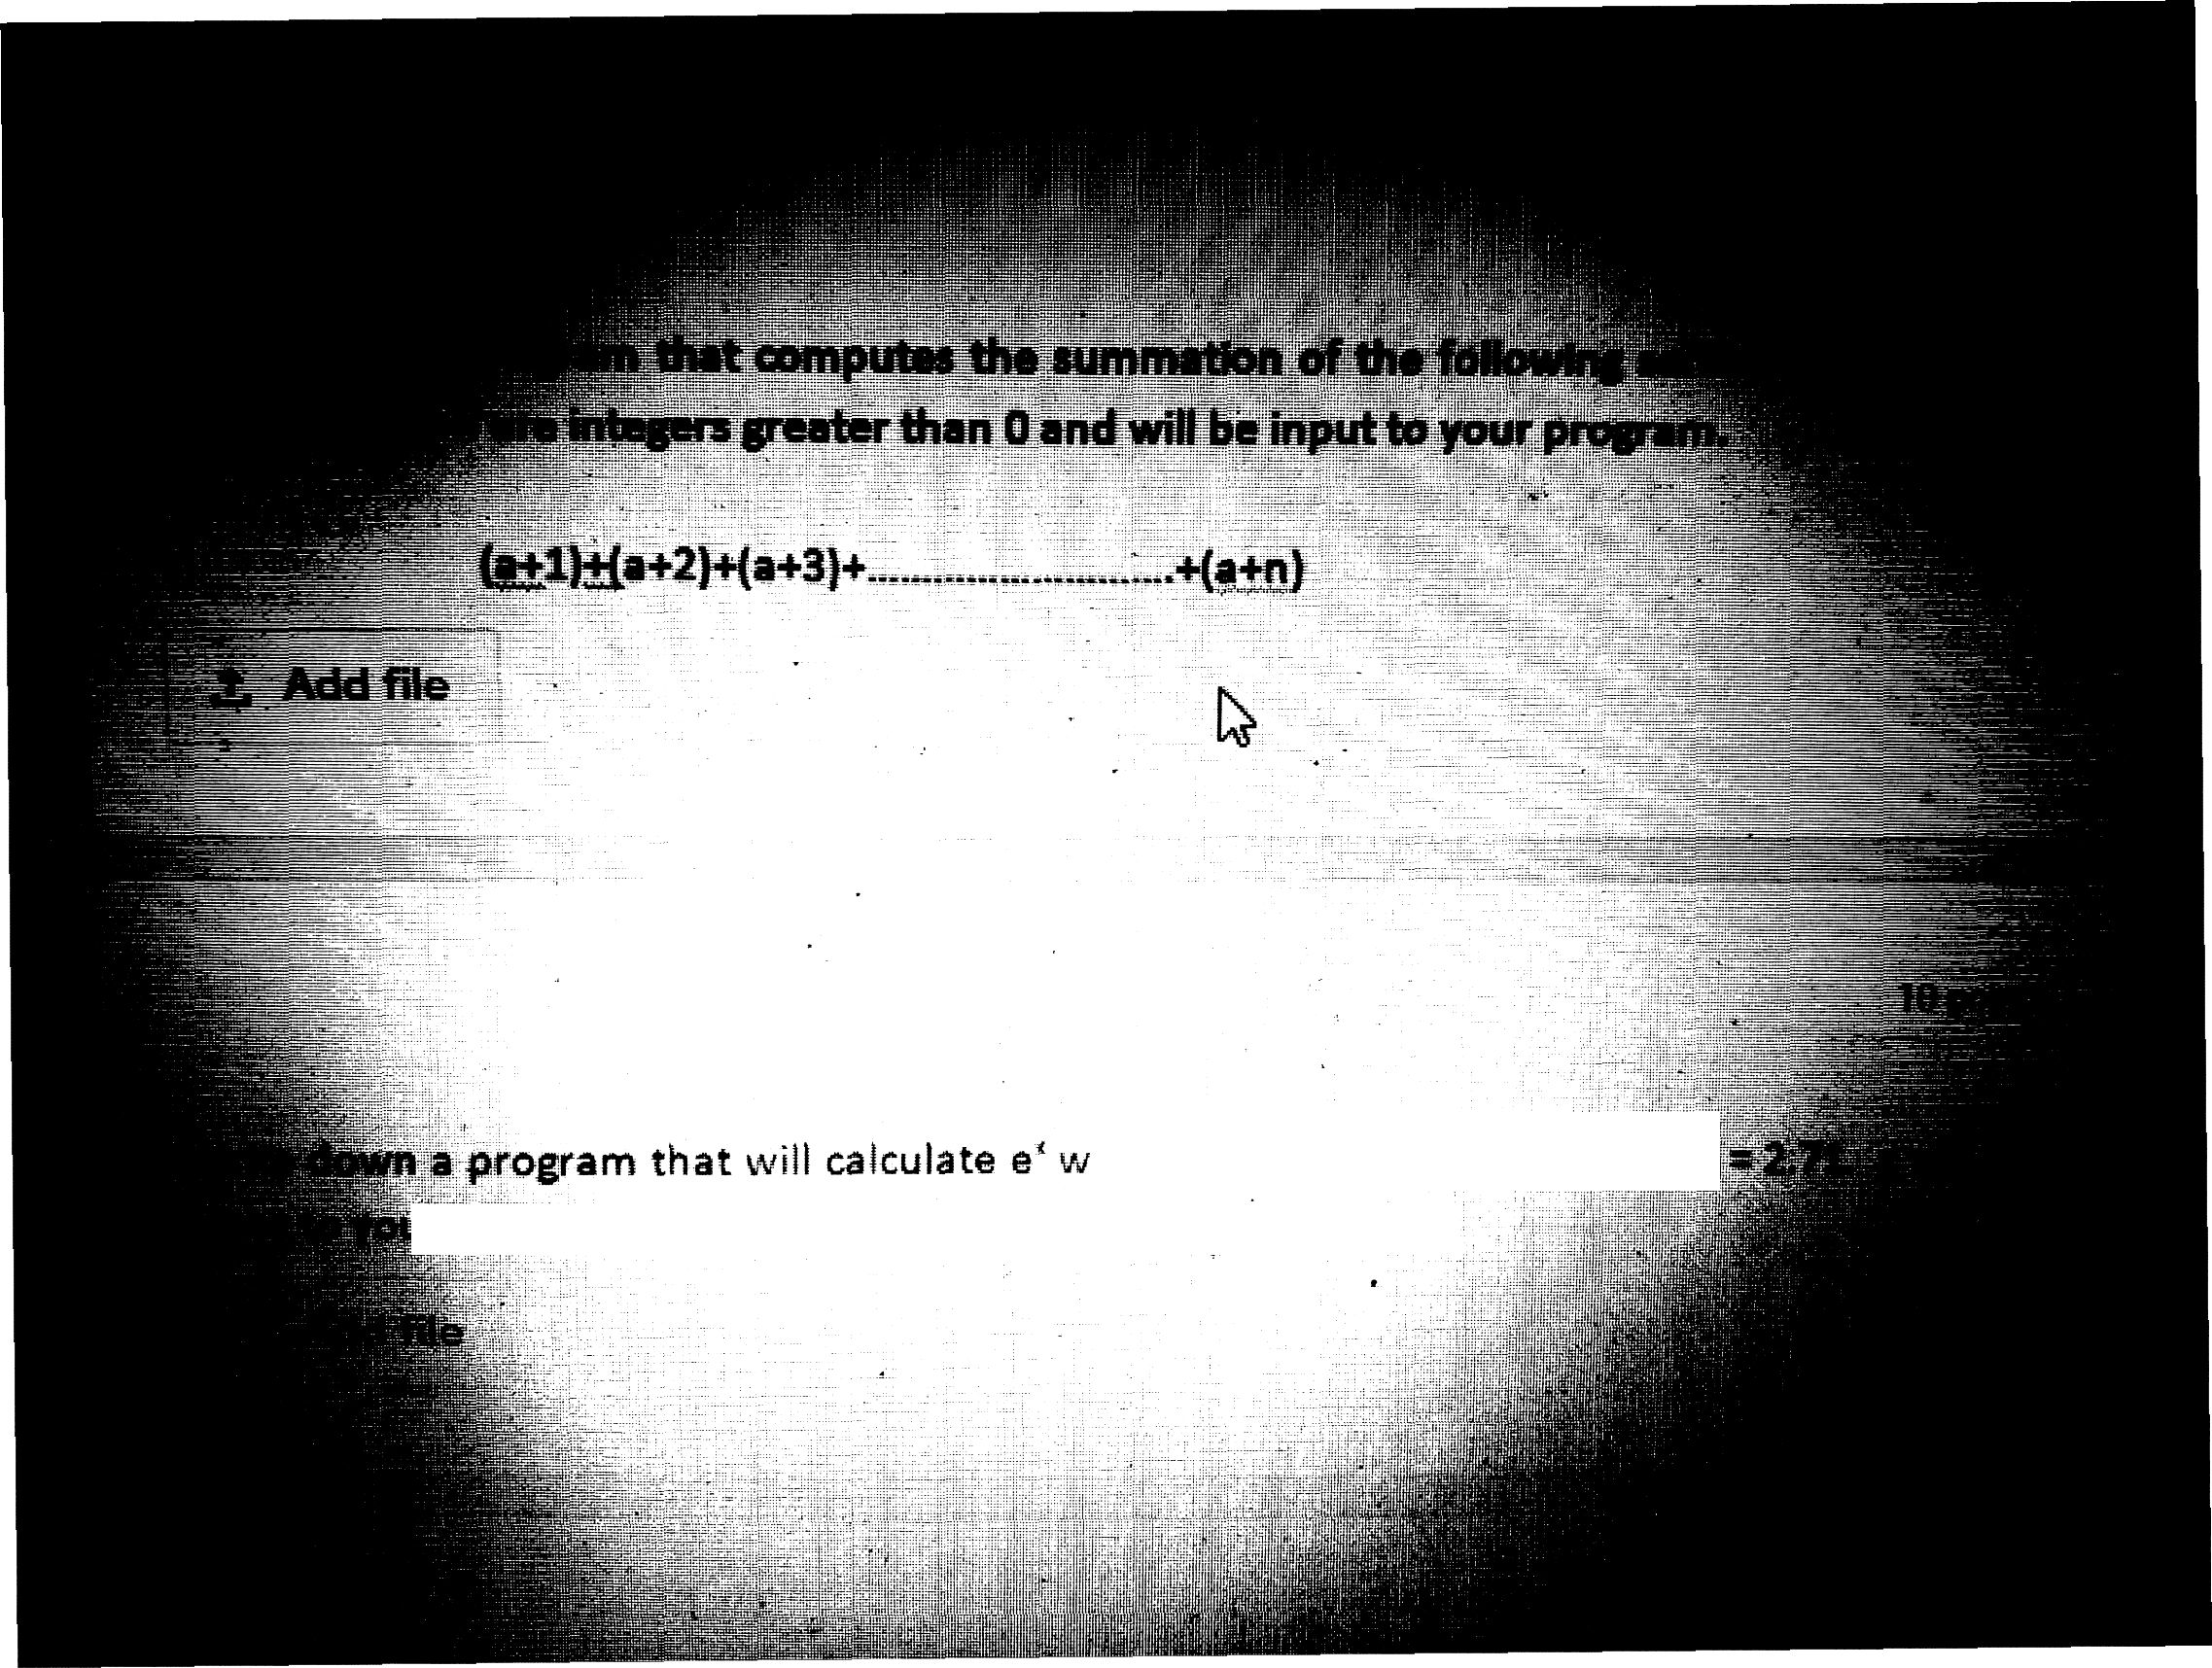

. .. . ’ “It'“\*

here x is a positive integer art@/

pragram. Find the equation of e’ from the Internet.

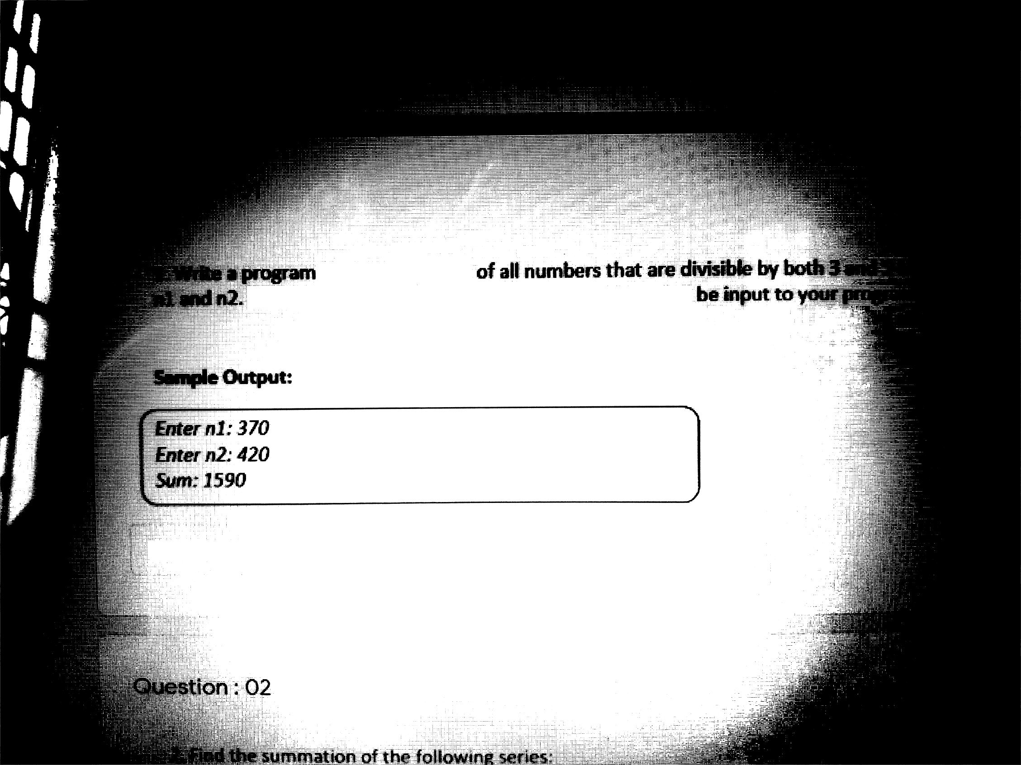

that displays sum

Aasume tkat n1is always loss than n2 and both wiłł

Add file

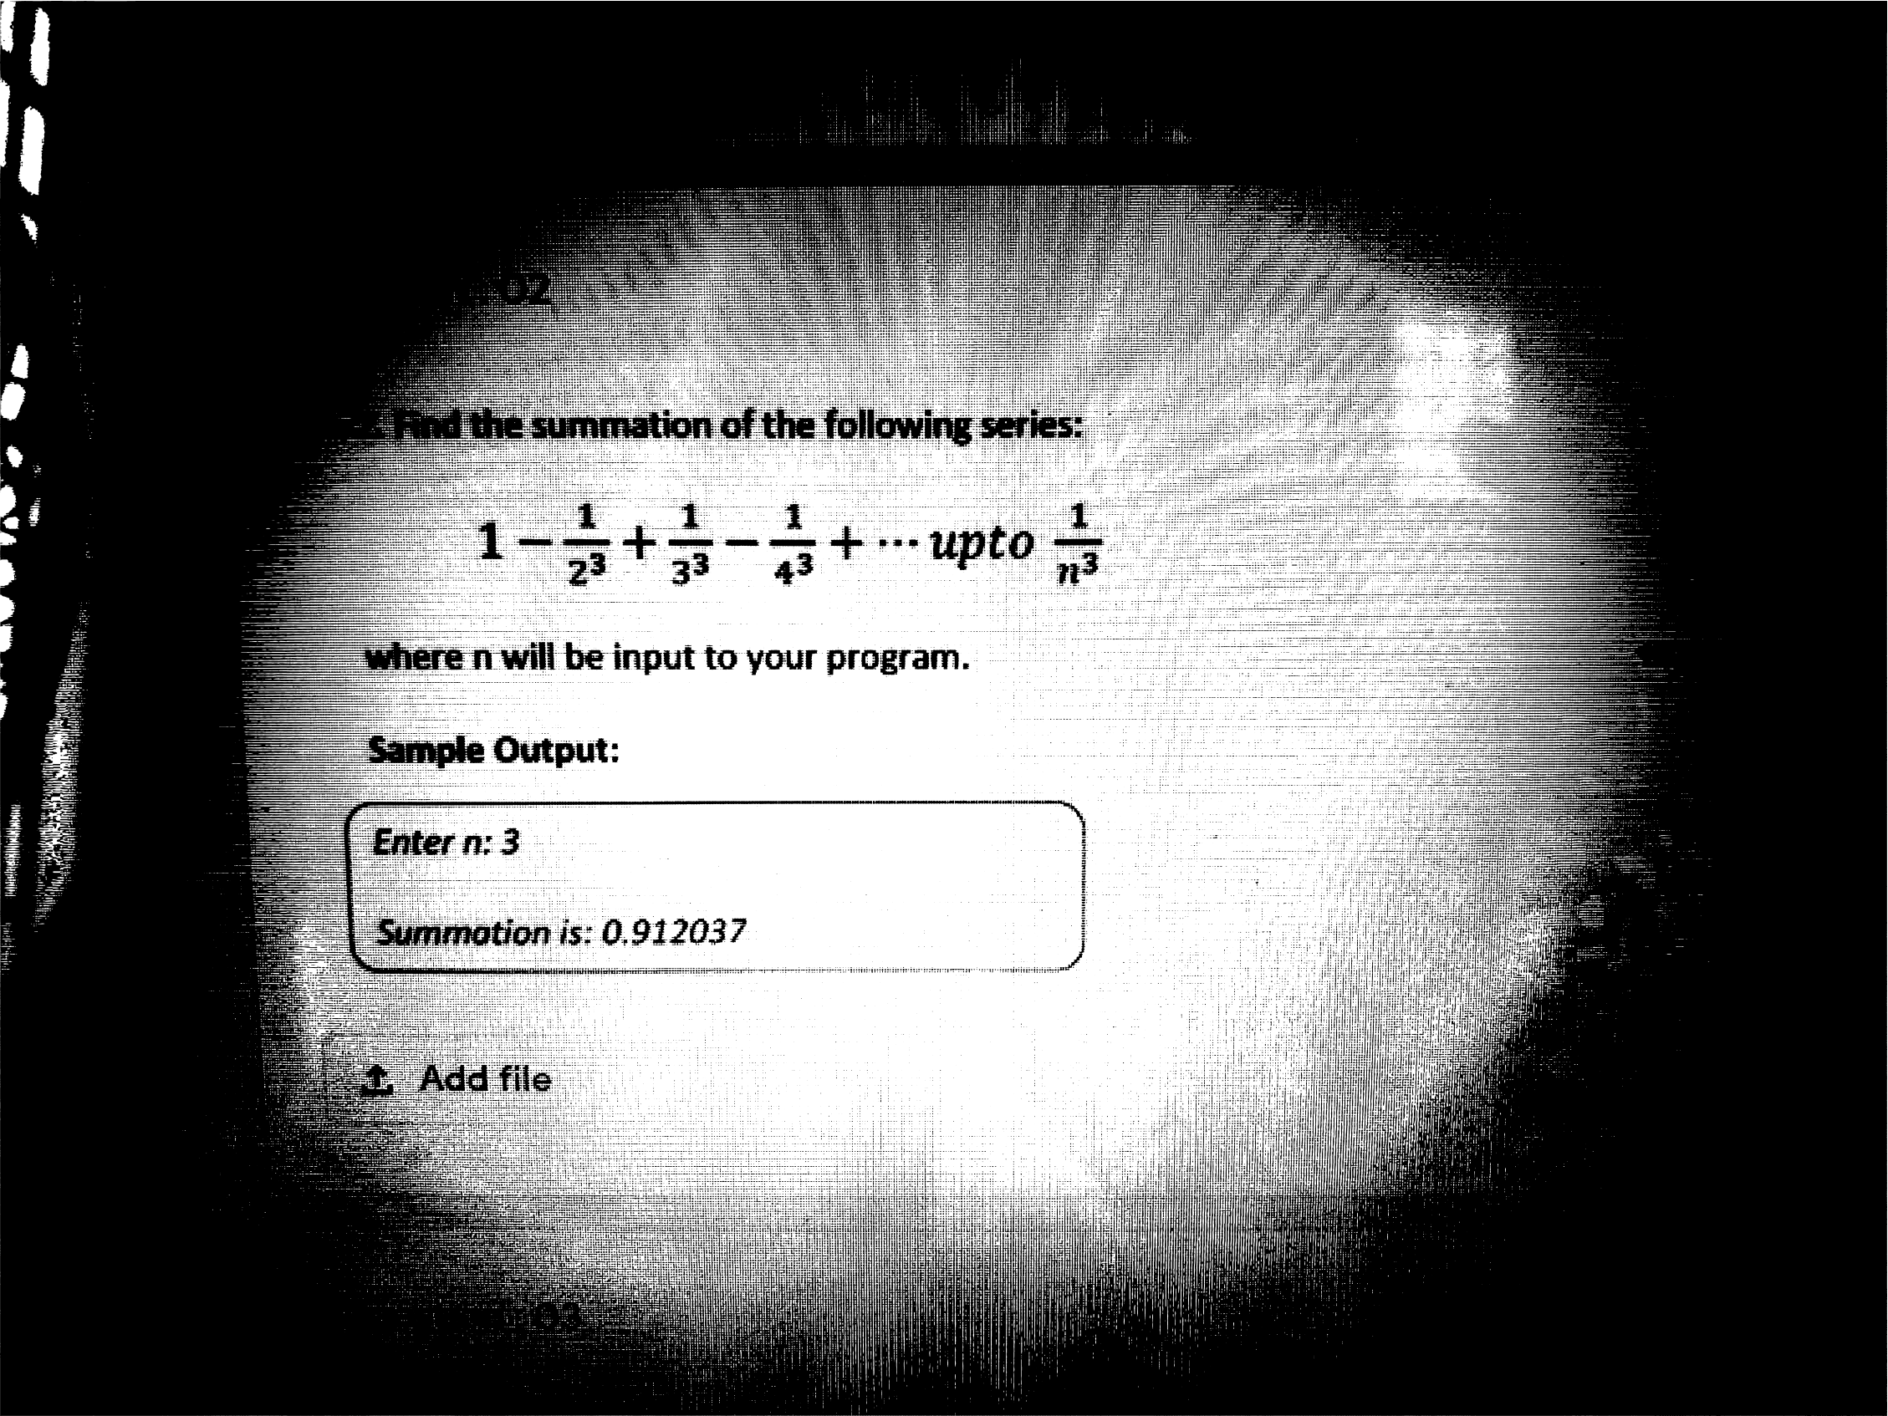

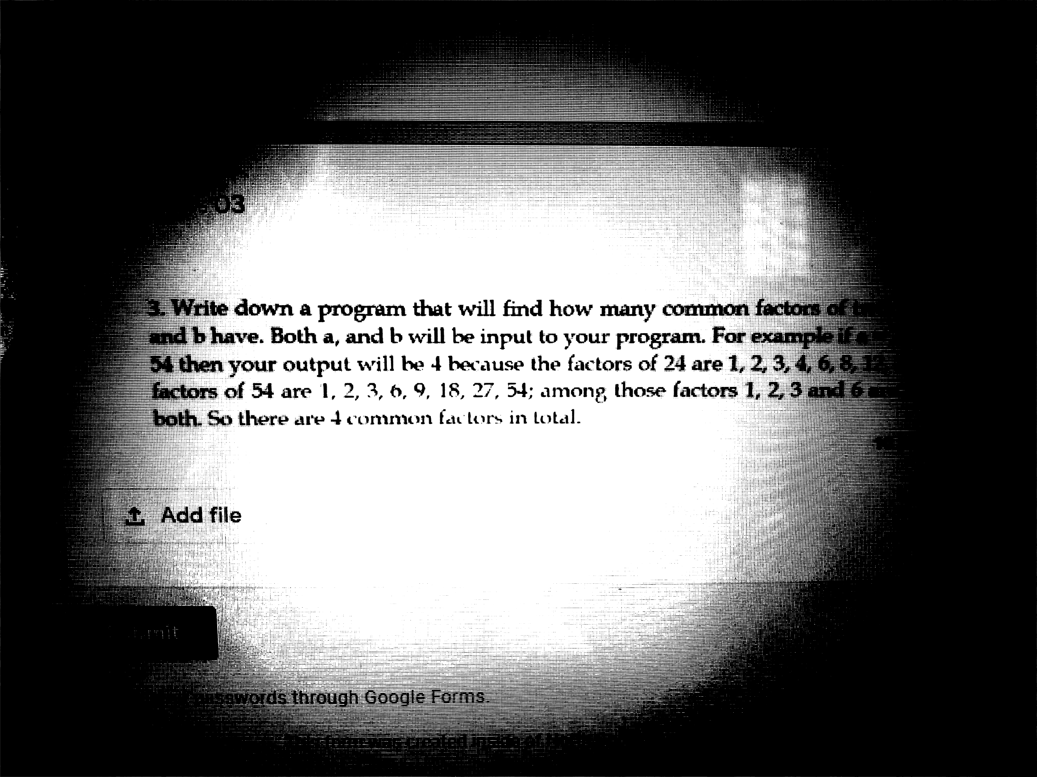

Faceboo k

— £J X

Write a C program to print the following pattern. The number of lines n in the pattern will be input to your program. Assume that n will be at most 26.

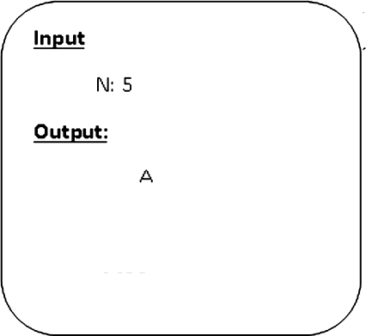

AB ABC ABCD

ABCDE

Write down a program that will determine Greatest Common Divisor (GCD) of 3 numbers a. b and c given as input.

FILL OUT A NEW

RESPONSE

You're editing your response. Sharing this URL allows

others to also edit youi response.

,0 Type here to search 



8/28/2020 ”



6:51

9 docs.googIe.com

Write a function name "dispIay_diagonaI" that displays the values on the diagonal of its 10 X 10 matrix parameter.

Add file

Write a function named "get winer" that determines who has won a game of tic-

tae-toe. The function should first check all rows to see whether one player occupies all the cells in one row, next check all columns, and then check the two diagonals. The function takes a two dimensional character array which represents the state of the game (filled with 'O' and 'X') and returns 0 or 1 or 2 ( 0 for draw, 1 for player one ('O') wins and 2 for player 2 ('X') wins)

,j¿, Add file

10 points

10 points

 



10:48

AA

9 docs.googIe.com

The name and photo associated with your Google account will be recorded when you upload files and submit this form. Not [emaz.ahmed@northsouth.edu?](mailto:emaz.ahmed@northsouth.edu) Switch account

Untitled Section

Write a function named "count_word" which takes a string 'str' and an integer 'n' as parameters and returns the number of words in 'str' which are 'n’ characters long.

,j:, Add file

Back

Submit

50 points

Never submit passwords through Google Forms.

This form was created inside of North South University.

Report Abuse



Name: ID: Sec:



1. Write down a void function STAR(n) that will print the ”symbol n times. Then from the main function take a user input x and use this function to print ”symbol x times.
2. Write down a SUM(x, y) function that will take two integers as parameter and will return sum of those two integers. Now from your main function take FOUR integers as input and use this function to calculate and print sum of those four numbers.
3. Write down a function factorial(n) that will take a number n as parameter and will return factorial of it. In your main function take an integer as input and use this function to determine and print factorial of it.

Sample Input/OutpUt:



OutpUt: 120

Sample Input/output:



Output: 6

1. Write down a function int powerOfTWO(int n) that calculates and returns 2". From main function take a number x as input and use the above function to calculate and print 2’. Assume x Is a positive integer.

Sample Input/output:



Output: 32

Sample Input/output: Input: 3

Output: 8

I otal: 2U, ñuboiission £zste:UI.IU.2U2U

Write a C’ program to take input for 2 students each one with marks in 5 subjects rind you have to display the marks using 2D array where the first integer of every row represents students ID. Then pnnt the total of their marks separately. 111 points



Enter marks for student with id 1: 90 93 04 95 96

Enter marks for student with id 2: 95 96 97 98 99 Marks of the two students:

1 90 93 94 95 96

2 95 96 97 98 99

Total marks for student with id 1: 468 Total marks PDF student with id 2: 485

1. Write a C program to play a game of two players and store their scores in a fiie. 10 points

Rules of the game:

* 1. First player will roll a die.
  2. Now, the second player will roll a die.
  3. If the second player rolls a die of the same a'alue as selected by the first player, he will

get points.

* 1. for’, the second player w ill first roll a die and then first player
  2. If first player rolls a die of the same value as by the second player then he will gel

points.

* 1. Repeat steps I to 5.
  2. Afler 20 rolls, player with higher points will 'isin the game.

Hint: You can use rand() function to generate a random number helw een l to 6. Follow the example: https://www.geeksforgeeks.orq'generating-random-number-range-c/

SEC:

CSE 115: Practice session: branching if-else

* + 1. Write down a program that will take a number as input and will print its absolute value without using any library function. The absolute value of a number is the magnitude of it ignoring its sign.

**Sample output** 1:

Enter number : 7 Absolute value 7

Sample output 2:

Enter number:- 7

Absolute value 7

* + 1. Write down a program that will take an integer as input and print YES if the number is divisible by 5 but not divisible by 7 and print NO otherwise.

Sample **output 1:**

Enter a number: 20 YES

**Sample output** 2: Enter a number: 70

* + 1. Given a 3-digit number as input by the user find and print its minimum digit. For example if the user input is 361 the output is 1.

Sample output 1:

Enter a 3 digit number: 361

mum is 1

Sample **output 2:**

Enter a 3-digit number: 497 Minimum is 4

* + 1. Write a C program that calculates Time difference of two cities. The time of both cities will be given as input and it can be in any order.

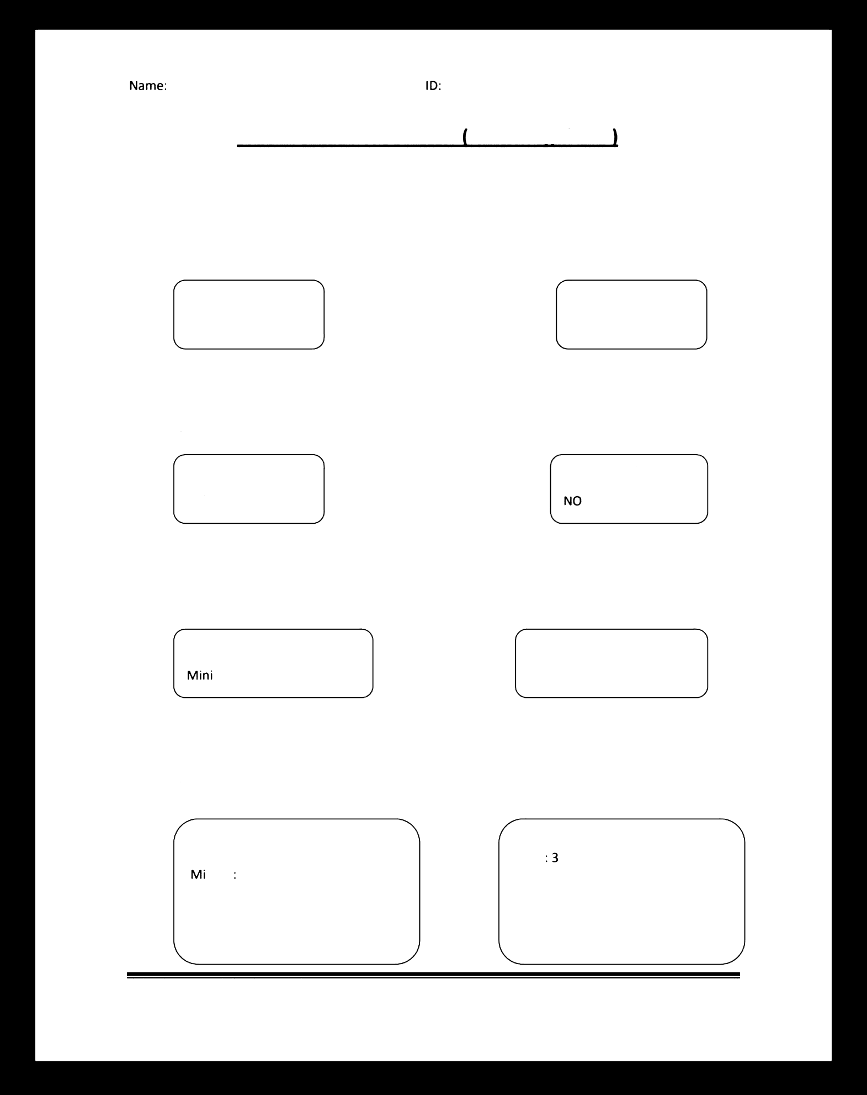**Sample output** 1:

Enter time of first city:

Hour: 12

nute 34

Enter time of second city: Hour: 11

Minute: 44

Difference: 0 hours S0 minutes CSE 115: Prof. Ashikur Rahman

**Sample** output 2:

Enter time of first city: Hour

Minute: 34

Enter time of second city: Hour: 7

Minute: 34

Difference: 4 hours 0 minutes

Page 1

SEC:

CSE 115: Practice session: Week 3 branching if-else

1. Write a C program that will take length of three sides of a triangle as input. The program will check whether it is possible to make a right angled triangle or nol. Otherwise, it will write "not possible". Recall that for a right angle triangle:

(a)2+(b)* = (c)2 where c is the largest side

Sample output 1. Sample output 2:

Enter side1: 3

Enter side2: 5

Enter side3: 4

Yes possible

Enter side1: 5

Enter side2: 4

Enter side3: 3

Yes possible

1. Write a C p 9Fam to check whether a character given as input is an alphabet or not.

**ut/out**

Enter a character: a a is an alphabet

Enter a character: F F is an alphabet

Enter a character: +

+ is not an alphabet

1. Write a C program that calculates the purchase amount after discount at the Agora shop. The discount rate depends on the purchase amount and summarized below:

|  |  |
| --- | --- |
| Purchase amount | Discount rate |
| First 3,000 TK | 10% |
| Next 5,000 TK | 15% |
| Remainin above 8,000 | 20% |

Sample output 1: Sample output 2: Sample output 3:

Enter purchase amount: 2000 Enter purchase amount: a00o Enter purchase amount: 9000

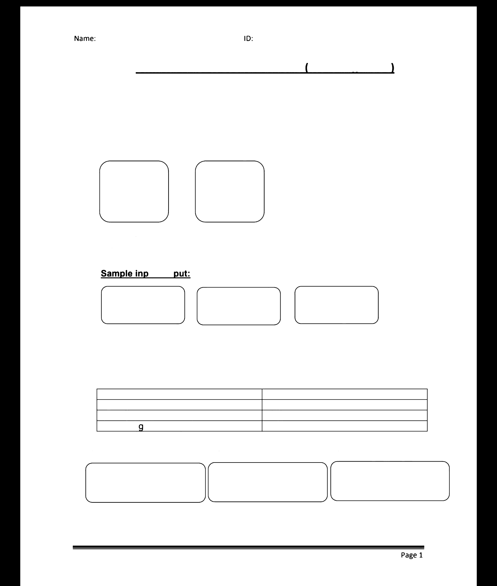

Payable amount: 1800

CSE 115: Prof. Ashikur Rahman

Payable amount: 3550 Payable amount: 7750

p CSE 115L: Progmmming Language I Lsb

 Online Quiz 01, Summer 2020, Sec: 13

# Total: 30, Time: 20 müi

###### Wrlte a C program to detcrmnc tlx: sqixirc antl tl» cubc of a n«rrÖer recen«xl as an

* 1. Write a C program to ake an lzier irpii antl deRrrrine if the given niarÖer ä ö rnuhipk: of 3 tziing s<fitch stnRnxmf. 10 pninfs
  2. Write a C program to ake an mer irpi£ antl deRrrrine ä the given niarÖer ä positiva,

rk:¡¡atrvc or zero usmg 4-elsc statcnxmt. 10 {xtints

##### C3E 115 - Programming Language I Summer 2020

Quiz 06, Mark - 20

* + 1. Write a program to create a linked IiSt Df integers until zero is entered. Always add the next element at the end of the I’ist. Then find the minimum and maximum values front the Ii5t dDd display tho5e numbers. 10
    2. Write a program in C to count the number of digits in a string using a pointer. 5

Quiz 04, Mark — 20

#### Write a program to find the third minimum number from an array of integers. Either you can randomly initialize the array with at least 10 integers or take input from user. 8

##### Write a program that will take two 5 x 5 matrices as in I multiply those matrices and then

print the result matrix. Write three functions for this. One is inputMatrix(int m[][5]) that will

#### take input of two matrices, the second is multiplyMatrix (int m1[](5], int m2[][5], int m3[][5] ) where m1 and m2 will be multiplied and the result will be m3. The third function is

printMatrix(int m[][5]) to output m1, m2 and m3. '

##### 3+6+3



Write a C program to find the third angle of a triangle iftwD angles are given.

*Expected Output :*

Input two angles of triangle separated by comma : 50,70

Third angle of the triangle : 60

* 1. Write a *ptagfam ta* reverse the case of an input alphabet. For example, if small c is given it will

print C and If capital Z is given it will output z.

* 1. Wrlte a progfaM to find me sum Of digits of an input number. Expected Output:

Enter a numbers 43Z5

Sum of dlgits• 14

* 1. Write a program to check whether a number is palindrome or noc A palindrome number is the same number when it is reversed. For example, t2321 or 233Z are palindrome numbers. Expected output:

Enter a number' 2332

The nttmber ‹s a palindrome

* 1. Write a program to find the factors of an input number.

Expected Output:

Enter a number: 26

Factors of 2G are: 1, 2, 13

* 1. Write a program to print the following table of n number of rews, where n is given as input.

34543

4567654

567898765

67890109876

7890123210987

89012345 I32109B

* 1. Write a program to print the following output, where m and n are given as input. (1, y) (2, 3) (3, 4) (n, n+1)

(2, 3) {3, 4) (4, 5) (n+1, n+2)

(m, m+1) (m+1, m+2) (m+n-1, m+n)

*-* CSE 115L: Programming Language I Lab

#### 'tpy $' Midterrn 01, Summer 2020, Sec: 13

##### * Total: 40, Time: 6tl min

1. Wrae a pmgram rl C tn take tluee raiirAers as user irpia arm prnt th rim&ers ri desceixling urder. Ill pnints

2. 



Saogde izqnzt/ output:

ABIDE

F€iHI

JKL

###### MN

1. Write a C prugram to print at tln even factors of a ram4ier received as an tour iqM.
2. C program to peribrm basic ar4lzmté operatioia which are adda*n, subtraction, nni ipkatñn, arxl division of two n rf›ers. Take two numbers as ver juts. Ask the her lbr a rreihirniical opmator and we switch can to perform the openition. lfi points

Enter two ninr1›crs. 3 6

Enter an operator ( ‘+’, ‘- ’, ‘*'. ‘/’): *



user inpul.

###### /''ai 1*/*ui.eh >aidelu ••pa .iho* yi«i Ie a''mga uJ «am+afñ*o>a

i\. AM 2 .1Ih. l\IIh sTudczns sale ’,Ih n trim Ikc a czzgc and name of Ifn›sc



Now rcmte a fsnctloa a«aic‹l firsJe.

1. Find tM Gndr ofcech st‹utczts zzsing thr C'gpa obtained From 8'ludenIs

£vnr6on.



###### 1.0•2.0 B



New” î'mto o f'uncdoo oaa •d suemattow

###### iT peram6cr valw!1 t priri fum ol all evea nua*t<'r from 63 to a3

1. If parameter vakse ls 0 pzlnt sumoF all z>dd number from L3 to 29



 

C quîz 05.docx

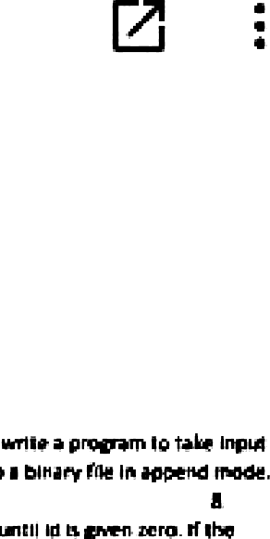

Quid 05. Mark - 15. Secôon 7

\. \o« arv CB a slest f•r œuue mer+aiment wum in ¢ ror t+el

eÎ zac seInfo+n\arav 1o, uoe ciecq tt+en same 1ruI filonIn



Each question bears 5 poi nts.

For function calling what are the differences between call by value and call by reference?

Explain with examples.

1. Write a program to find all the prime numbers between 1 to n, where n is the user input. Write this prDgram using a function int *isPrime* {int nJ that will return if n is a prime number or not.
2. Write a recursive function that will sum all the even numbers between 1 to n, where n is usef

Input.

1. Write a recursive function thdt will Sum the d igits of a number n. For example, if n is 3425 then

the answer is 14, which i‹ the result nf 3+4+2+5.

Facebook

— £J X



Suppose you are appointed as a programmer in Rupali Bank and you are in charge of calculating bank fees payable at the end of a month by all clients having a checking account with the bank. In every month the bank charges all checking account holders using the following rules:

Number of Transactions

F irst } 0 t ransam ion s N ext J 0 I ran*act ions N ex r 10 I r ansact +ons N ext J 0 t ransack ons

T Jy fun he’ t ran sack on s

Free

fi T k. per - ra r •ect on 7 ? T k . per I r ansact ion 10 I k pe r t ra nsact ion

12.? 0 T k per I r ans act ion



*“*

3: PM

8/28/2020

,0 Type here to search

FILL OUT A NEW

RESPONSE

You're editing your response. Sharing this URL allows

otheis to also edit youi response.

W r te doc'o a progr am 'h aj reads a cl ‘ent’s t otal number of I lantact ‹ons in a mont h and

*Sri n•s I* he amo un• t o be paid by t he '-lie nI as a bank fee at I he encl of • he mont h.



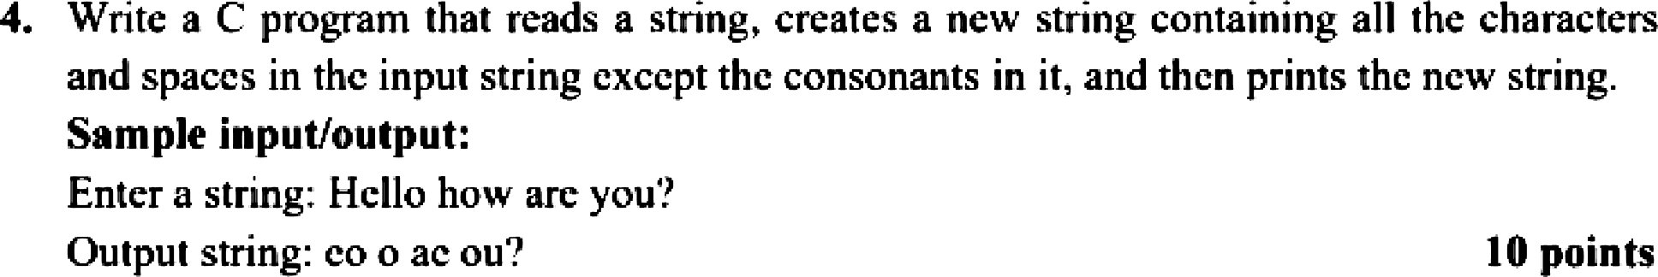

CSE 115L: Practice Problems (String)

1. Take two string inputs, calculate lengths of both and display the smaller one. If the lengths are equal display the first one.

Sample **Input/output:**

Enter string 1: How are you

Enter strlng 2: I am fine how about you How are you

1. Print the ASCII values of all characters in a string given as input.

Sample Input/output:

Enter string: A LIE

ASCII Values: 65 76 73 69

1. Take a string Input which wlll Include both uppercase and lowercase letters. Convert all lower case letters to uppercase letters and all uppercase letters to lowercase letters. Finally display the string.

Sample lnputgoutput:

Enter string: Today is THURSDAY tODAY IS thursday

1. Take a string Input and determine whether the input is a valld password or not. A password is valid if It satisfies the following conditions:
   * A password must contain at least 6 characters
   * It must contain at least one small letter, at least one capital letter and at least one symbol or digit.

I n

Enter string: Doob:Ahare_JibonI

VALID PASSWORD

### CSE 115L: Practice Problems (String)

1. Take two string inputs, calculate lengths of both and display the smaller one. If the lengths are equal display the first one.

Sample **Input/output:**

Enter string 1: How are you

Enter strlng 2: I am fine how about you How are you

1. Print the ASCII values of all characters in a string given as input.

Sample Input/output:

Enter string: A LIE

ASCII Values: 65 76 73 69

1. Take a string Input which wlll Include both uppercase and lowercase letters. Convert all lower case letters to uppercase letters and all uppercase letters to lowercase letters. Finally display the string.

Sample lnputgoutput:

Enter string: Today is THURSDAY tODAY IS thursday

1. Take a string Input and determine whether the input is a valld password or not. A password is valid if It satisfies the following conditions:
   * A password must contain at least 6 characters
   * It must contain at least one small letter, at least one capital letter and at least one symbol or digit.

I n

Enter string: Doob:Ahare_JibonI

VALID PASSWORD

1. Take two string inputs, calculate lengths of both and display the smaller one. If the lengths are equal display the first one.

**Sample Input/output:**

Enter string 1: How are you

Enter string 2: I am fine how about you How are you

1. Print the ASCII values of all characters in a string given as input.

Sample Input/output:

Enter string: A LIE

ASCII Values: 65 76 73 69

1. Take a string input which will include both uppercase and lowercase letters. Convert all lower case letters to uppercase letters and all uppercase letters to lowercase letters. Finally display the string.

Sample Input/output:

Enter string: Today is THURSDAY tODAY IS thursday

1. Take a string input and determine whether the input is a valid password or not. A password is valid if it satisfies the following conditions:
   * A password must contain at least 6 characters
   * It must contain at least one small letter, at least one capital letter and at least one symbol or digit.

Sample Input/output:

Enter string: Doob:Ahare Jibon! VALID PASSWORD

CSE 115L: Practice Problems (String)

1. Write a program in C to convert a string to uppercase using library function. Test Oata:

Input a string in lowercase: the quick brown fox jumps over the lazy dog

*Expected output:*

Here is the above string in UPPERCASE:

THE QUICK BROWN FOX JUMPS OVER THE LAZY DOG.

1. Write a program in C to print individual characters of string in reverse order (do not use library function except strlen() and gets().

Test Data:

Input the string : resource.com

*Expected Output:*

The characters of the string in reverse are:

m o c . e c r u o s e r

1. Write a C programming to find the first repeated character in a given string.

Test Data:

Input a string: resource

*Expected Output.’*

Input a string: The first repeated character in resource is: r

ID:

Home Assignment: 02

Section:

* 1. Write a C program that will take a String and a word as input as search for the word in the String. If the word is present in the String, print the starting and ending position of the word, if not print word is not in the string. If word is present multiple times only consider the one that appeared first.

Sample Input:

Enter a String: Hello World! Enter your search word: World

Sample Output:

World starts at 7th and finishes at llth position.

Sample Input:

Enter a String: How are you doing? Enter your search word: do

Sample Output:

do starts at l3th and finishes at l4th position.

* 1. Write a C program that takes a String as input and find the smallest word in that String.

Sample Input:

Enter a String: Come to my House.

Sample Output: Smallest word: to





 x -F

ü docs.googIe.com 

O TP MNK O

Write down a program that will take a sentence as input from the user and then will take three words as inout and print them in a sorted order. Use strcmp library function in your solution. For example if three inputs are APPLE. ORANGE and MANGO your output will be APPLE MAf4GO ORANGE

Write dozen a structure that can store an employe e s record having t\’vo attributes (a) Employee ID. and (b) salary. Using this structure take N employees’ information as input where N will also be input to your program. Write down a function that will take employees information as parameter and will return number of employees getting more than SOOOO

all elements in



find the summation of



11:51 AM

0/5/2020

,0 Type here to search



t. Write a C prngram to calculate the area and perimeter of a rectangle using pointer and the

following function header.

void greuPeri{int *I, int *w) lti point

2. Write a fi program that reads a string from uscr and thcn prints the number of times different lcttcrs appear in that string. IO points Sample input/output:

Enlcr a string: Hcllo how arc you'?

#### Frequencies of letters in the input .string: a/A: 1. e/E: 2, h/H: 2, l/L: 2, o/C›: 3, r/R: 1, u/U:

##### 1, w/W: 1, y/Y: 1,

z. Write C program to find ihc number capital letters and the small letters in an input string to convert the capital letters to small letters and convert the small letters to capital letters and thcn print the output string, You Gannet us any library function. 10 points

##### Sample input/output:

hnier a string: This is North South University.

##### Outpui siring: tHIS IS nORTH SOUTH uNIV ERSITY.

Assignment:

* + 1. Declare the structure* needed for your project. Declare a 100 element array of that structure. ‹Also declare an integer voriahle called num (with Initial value zcrol o’hich indicates the number of *i•atid (i.r..* elements read from user) elements in that army of structure sarlables. Declare the structure, urrny of structure, and num globally loutsidc nll functionsl and declare them before main function.

*\* If yuu need mtire then one struct. you must declare them as* »'*elf: for e.g. u'hen ¡'our want to use a nested ctructure.*

* + 1. In main I‘unctiun, read the number of elements te be entered by user and assign that s'alue !o num fask ser ie enter a value <= !00). Then read first num elements of your array of struct from user.

In main function, print the volid elements in your array of struct using a loop.



#### Write a program that will take input of n number of students’ information as |id, name, cgpa] and then create a file to save the information as the following format. 20

No of Students: 50

SL# Id name CGPA

|  |  |  |  |
| --- | --- | --- | --- |
| 1 | 12051 | Rahim Uddin | 3.5 |
| 2 | 12052 | KarimUddin | 3.5 |
| 2 | 12053 | Hakim Uddin | 3.5 |

S0 12100 !taIim Uddin 3.5

# Total: 20, Time: 25 min

###### Create a struct called “Student” with the following members:

* 1. Name

###### Date of Birth (D.O.B., in short)

* 1. Height

Create an array of x student variables, where x is the 5'h digit of your ID then read user input to

fill up this array. Then display the info of the student who is the oldesl. 10 points

1. Writc a C program to take a 2D array as a user input and dcicrmine thc .smallc.st and thc l8Tg0.$t numbers fnrm each row. Then display the nuipuis in ihe console. I(I points

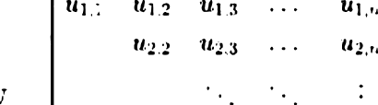

CSE 115 — Programming Language I Summer 2020

Final Exam, Mark — 30

Answer any 6 out of 7 questions. Each question carries 5 points.

1. Write a program to take input of 9 x 9 matrix and then print the upper triangle of the matrix. An example of upper triangle is given below: S
2. Write a function mystrIen(char str[]) that will return the length of a string. You are not allowed to use any string functions.
3. Write a recursive function mystrrev(char ’str) that will display the string in reverse order. Do not use any string functions as well as use the pointer variable ”str. 5
4. Write a program to take input of 100 students in an array of structure where the structure field is like Student |id:int, name:string cgpa:float], use typedef to define the structure name as Student. 7
5. Write a function writeFiIe(Student ”ptr) that will save 100 students record in a binary file called student.db that will be opened for writing in that same function. 5
6. Write a function readFile() that will open the student.db file created in question 5 and then print the student information in console output. 5
7. Write a program to take input of 100 integers in an array then find the average of numbers that are in between 20 and 80. For example if an array contains [10, 40, 15, 20, 30, SO] then the average will be (40+20+30) / 3 = 30. 5